HFDST 5

5-22 Properties The properties of air are R = 0.287 kJ/kg.K and c_{p} = 1.008 kJ/kg.K (at 350 K from Table A-2b)
Analysis (a) The diameter is determined as follows:
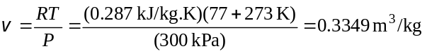
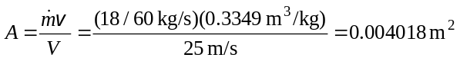
300 kPa
77°C
Air
25 m/s
18 kg/min
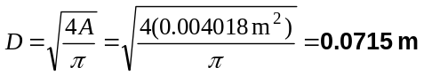
(b) The rate of flow energy is determined from
(c) The rate of energy transport by mass is
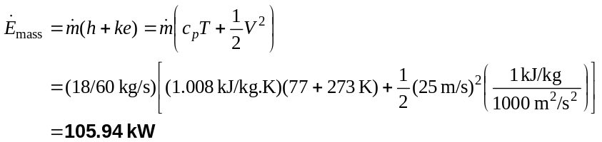
(d) If we neglect kinetic energy in the calculation of energy transport by mass
Therefore, the error involved if neglect the kinetic energy is only 0.09%.

5-32 Assumptions 1 This is a steady-flow process since there is no change with time. 2 Air is an ideal gas with constant specific heats. 3 Potential energy changes are negligible. 4 There are no work interactions. 5 The diffuser is adiabatic.
Properties The specific heat of air at the average temperature of (20+90)/2=55°C =328 K is c_{p} = 1.007 kJ/kg⋅K (Table A-2b).
Analysis There is only one inlet and one exit, and thus 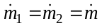. We take diffuser as the system, which is a control volume since mass crosses the boundary. The energy balance for this steady-flow system can be expressed in the rate form as
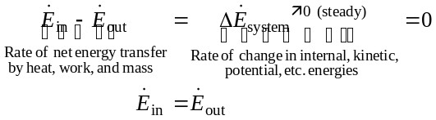
AIR
100 kPa
20°C
500 m/s
200 kPa
90°C
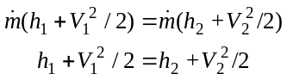
Solving for exit velocity,
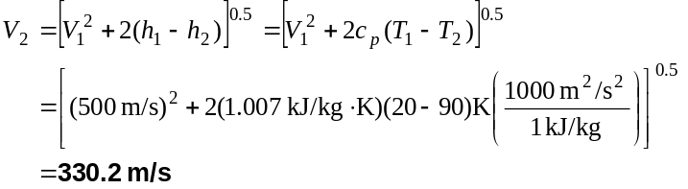

5-55 T₂ = 267,3°C

5-65 x=0,422
5-84 Assumptions 1 Steady operating conditions exist. 2 The heat exchanger is well-insulated so that heat loss to the surroundings is negligible and thus heat transfer from the hot fluid is equal to the heat transfer to the cold fluid. 3 Changes in the kinetic and potential energies of fluid streams are negligible. 4 Fluid properties are constant.
Properties The specific heats of cold and hot water are given to be 4.18 and 4.19 kJ/kg.°C, respectively.
Analysis We take the cold water tubes as the system, which is a control volume. The energy balance for this steady-flow system can be expressed in the rate form as
Hot water

100°C
3 kg/s
Cold Water
15°C
0.60 kg/s
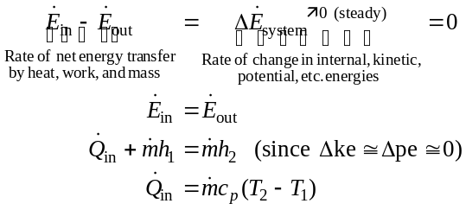
Then the rate of heat transfer to the cold water in this heat exchanger becomes
Noting that heat gain by the cold water is equal to the heat loss by the hot water, the outlet temperature of the hot water is determined to be

5-117 406 K

5-130 Assumptions 1 This is an unsteady process since the conditions within the device are changing during the process, but it can be analyzed as a uniform-flow process by using constant average properties for the steam leaving the tank. 2 Kinetic and potential energies are negligible. 3 There are no work interactions involved. 4 The direction of heat transfer is to the tank (will be verified).
Properties The properties of water are (Tables A-4 through A-6)
STEAM
2 MPa
Q
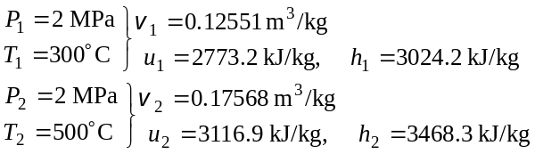
Analysis We take the tank as the system, which is a control volume since mass crosses the boundary. Noting that the microscopic energies of flowing and nonflowing fluids are represented by enthalpy h and internal energy u, respectively, the mass and energy balances for this uniform-flow system can be expressed as
Mass balance:
Energy balance:
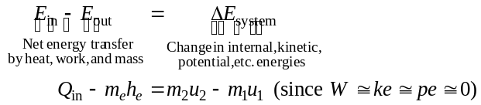
The state and thus the enthalpy of the steam leaving the tank is changing during this process. But for simplicity, we assume constant properties for the exiting steam at the average values. Thus,
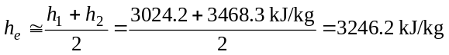
The initial and the final masses in the tank are
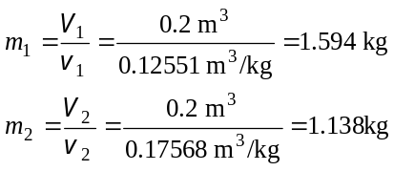
Then from the mass and energy balance relations,
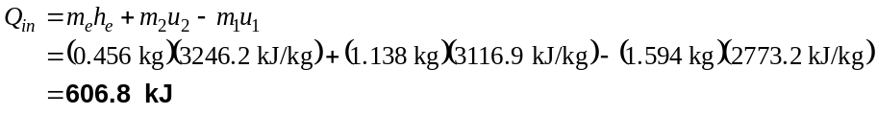

5-141 The rate of accumulation of water in a pool and the rate of discharge are given. The rate supply of water to the pool is to be determined.
Assumptions 1 Water is supplied and discharged steadily. 2 The rate of evaporation of water is negligible. 3 No water is supplied or removed through other means.
Analysis The conservation of mass principle applied to the pool requires that the rate of increase in the amount of water in the pool be equal to the difference between the rate of supply of water and the rate of discharge. That is,
since the density of water is constant and thus the conservation of mass is equivalent to conservation of volume. The rate of discharge of water is
The rate of accumulation of water in the pool is equal to the cross-section of the pool times the rate at which the water level rises,
Substituting, the rate at which water is supplied to the pool is determined to be
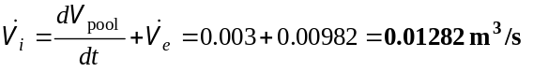

5-143 2,46 kg/m³

5-148 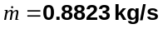; 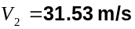

5-151 Assumptions 1 The process in the mixing chamber is a steady-flow process since there is no change with time. 2 Kinetic and potential energy changes are negligible. 3 There are no work interactions. 4 The device is adiabatic and thus heat transfer is negligible.
20°C
T_{mix}
Tank
T₁ = 80°C
T₂ = 60°C
20°C
0.06 kg/s
Mixing chamber
Properties The specific heat and density of water are taken to be c_{p} = 4.18 kJ/kg.K, ρ = 100 kg/m³ (Table A-3).
Analysis We take the mixing chamber as the system, which is a control volume since mass crosses the boundary. The energy balance for this steady-flow system can be expressed in the rate form as
Energy balance:
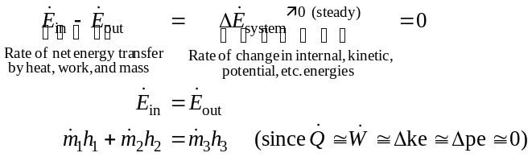
or (1)
Similarly, an energy balance may be written on the water tank as
(2)
where 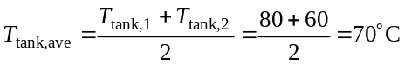
and
Substituting into Eq. (2),
Substituting into Eq. (1),
